Title: Payment Transaction Management System
Project Title: E-Commerce Order Management System

Project : E-Commerce Order Management System
Student Name : Yoga moorthy S
Register Number : C4S38025
Department : III - AI
Course : Artificial intelligence (AI)
Academic Year : 2026 – 2027

1. Create Database
CREATE DATABASE PaymentManagement;
USE PaymentManagement;

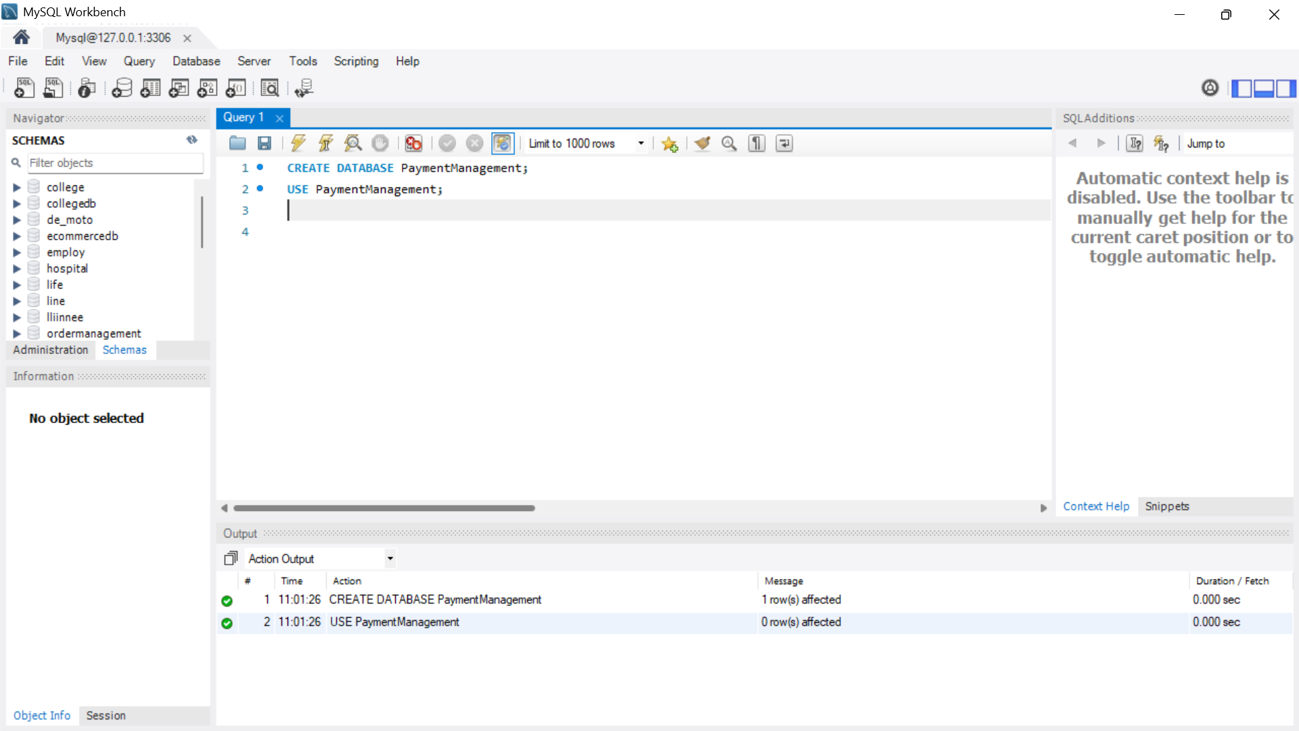

2. Create Payment Table
CREATE TABLE Payment (
Payment_ID INT PRIMARY KEY AUTO_INCREMENT,
Customer_Name VARCHAR(100) NOT NULL,
Amount DECIMAL(10,2) NOT NULL,
Payment_Mode VARCHAR(30) NOT NULL,
Payment_Date DATE NOT NULL,
Payment_Status VARCHAR(20) NOT NULL
);

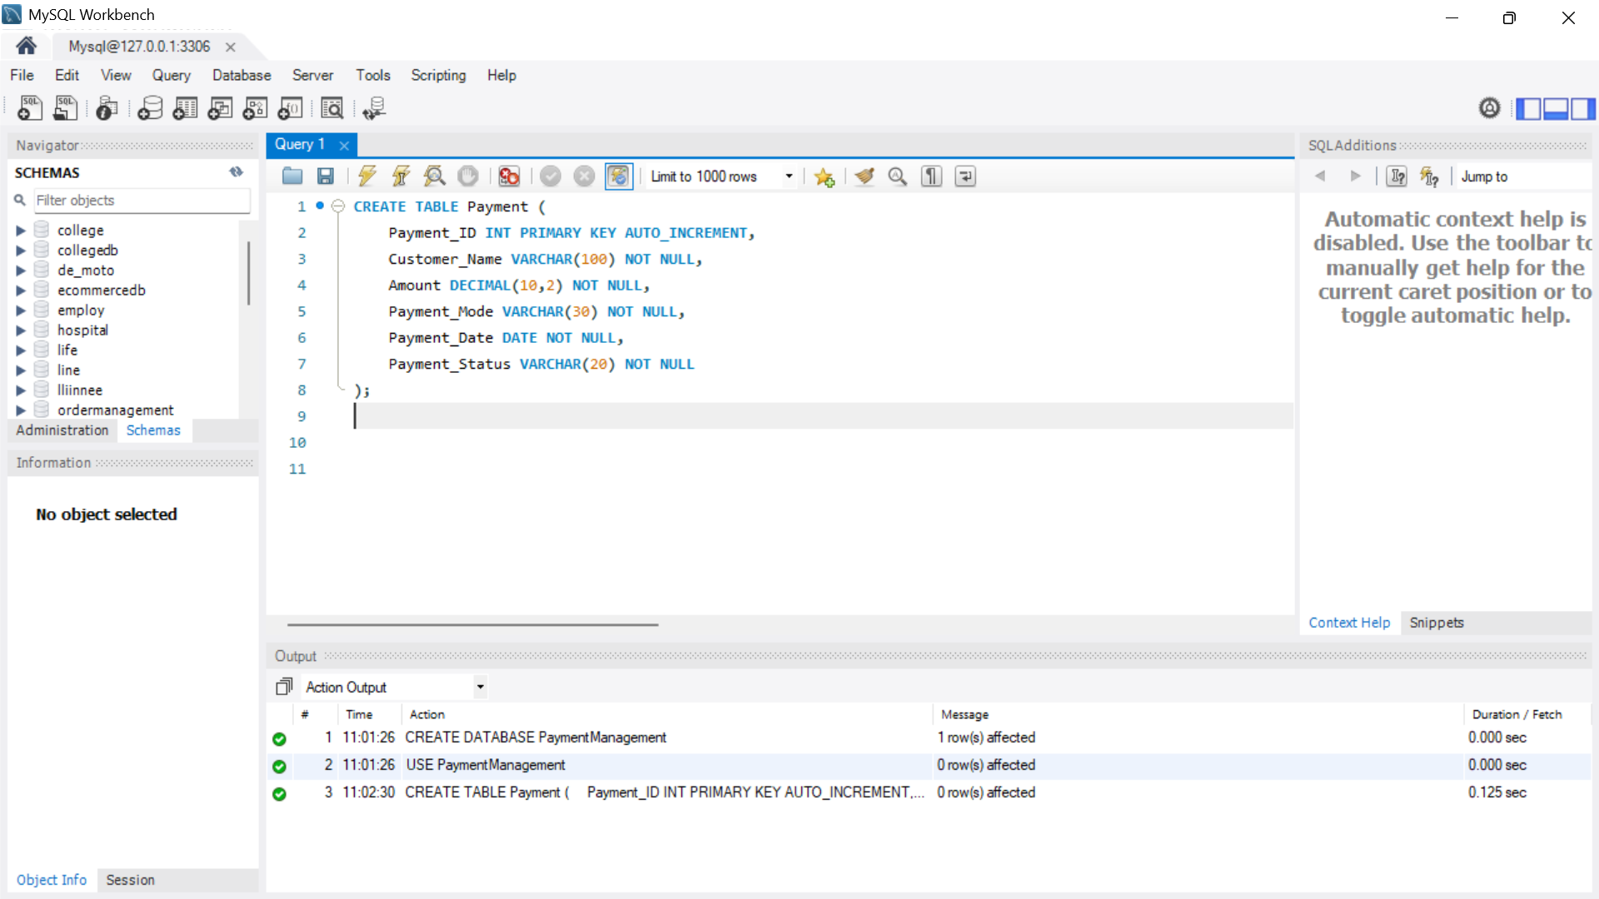

3. Insert Payment Details
INSERT INTO Payment
(Customer_Name, Amount, Payment_Mode, Payment_Date, Payment_Status)
VALUES
('Arun', 1500.00, 'UPI', '2026-08-10', 'Successful'),
('Priya', 2500.00, 'Credit Card', '2026-08-11', 'Successful'),
('Kumar', 1200.00, 'Debit Card', '2026-08-11', 'Failed'),
('Divya', 800.00, 'UPI', '2026-08-12', 'Successful'),
('Rahul', 3500.00, 'Net Banking', '2026-08-13', 'Failed');

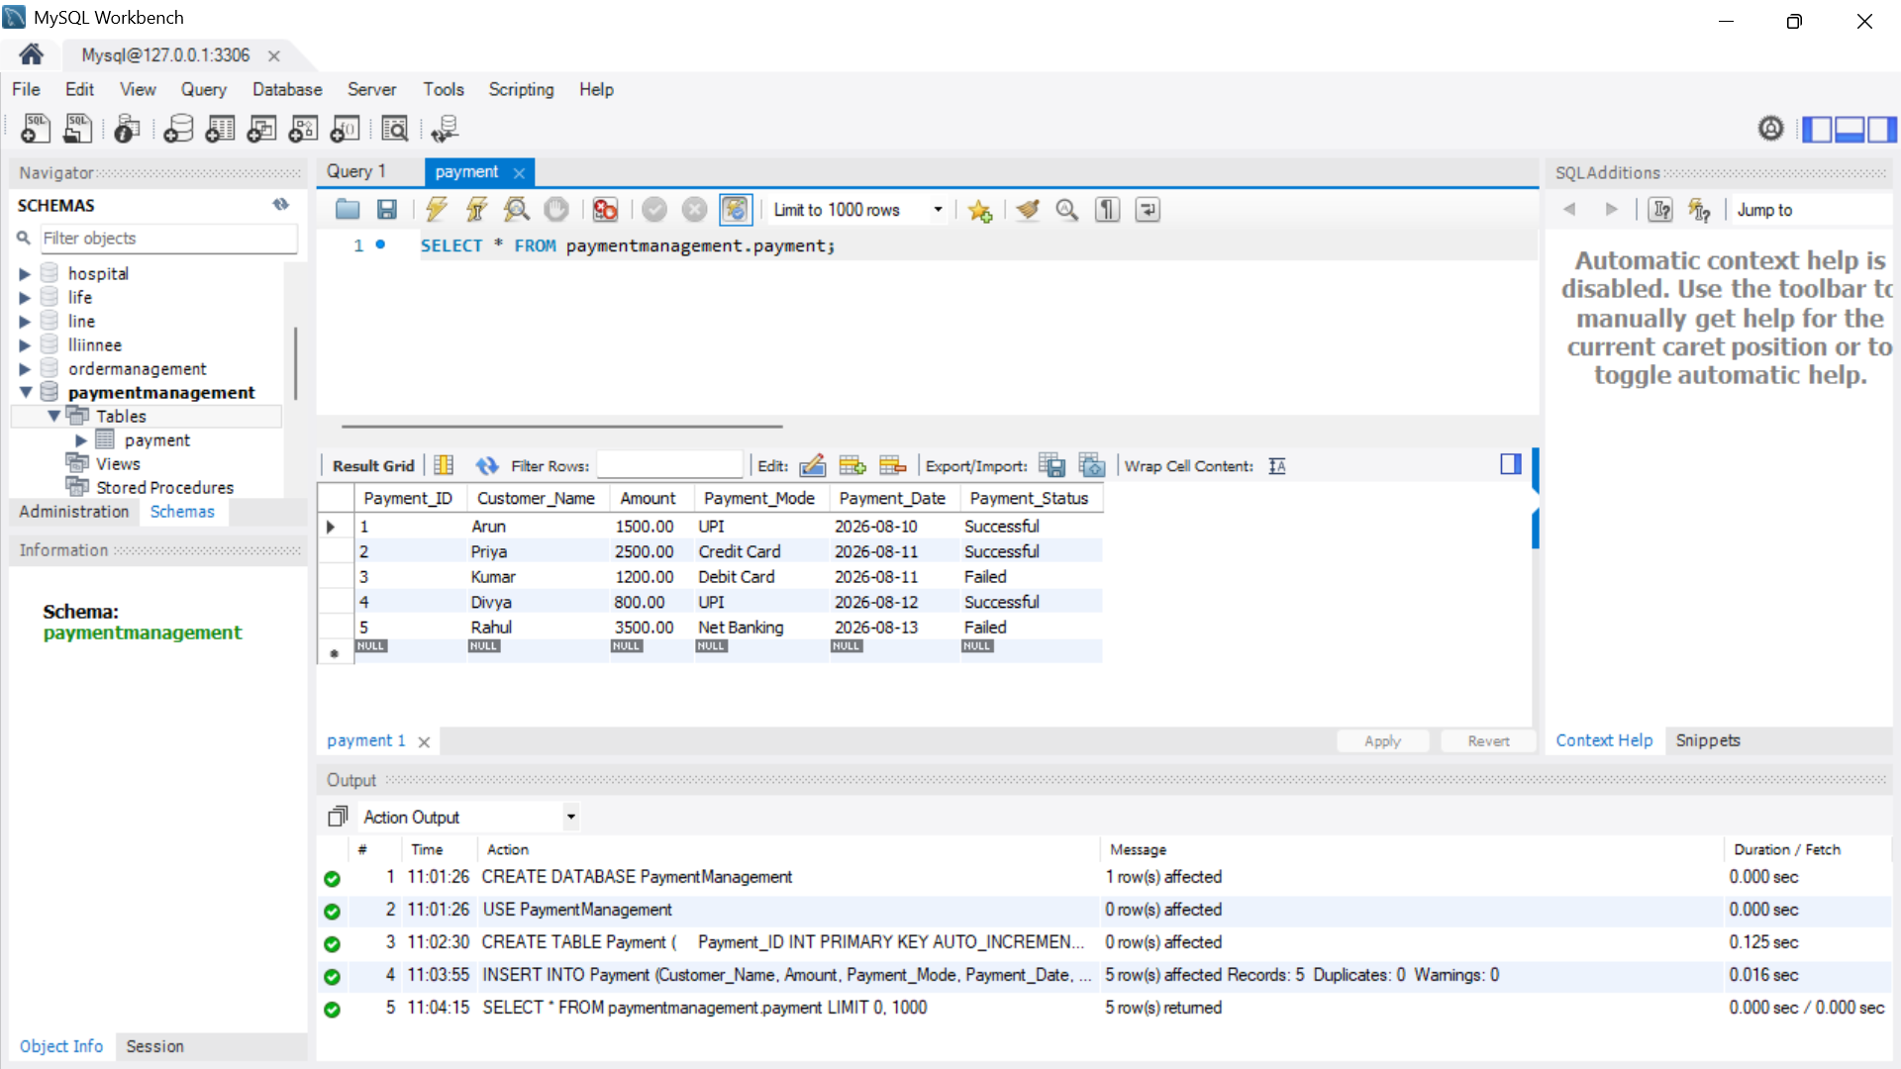

4. View All Transactions
SELECT * FROM Payment;

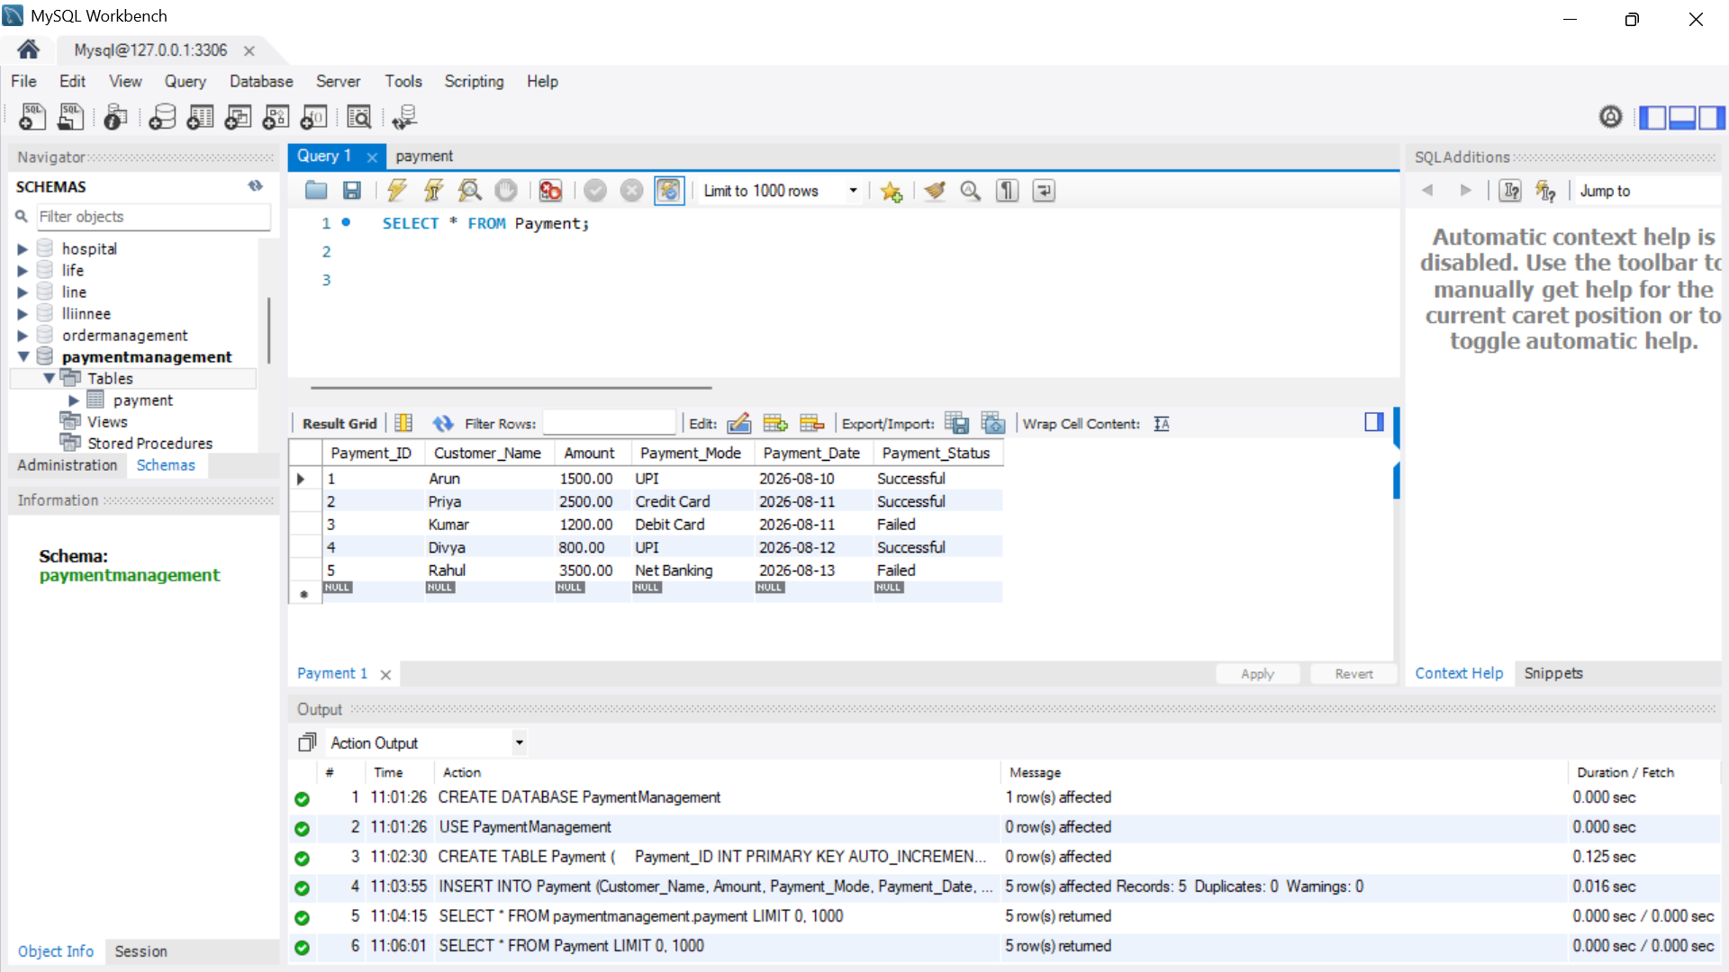
5. Display Successful Transactions
SELECT *
FROM Payment
WHERE Payment_Status = 'Successful';

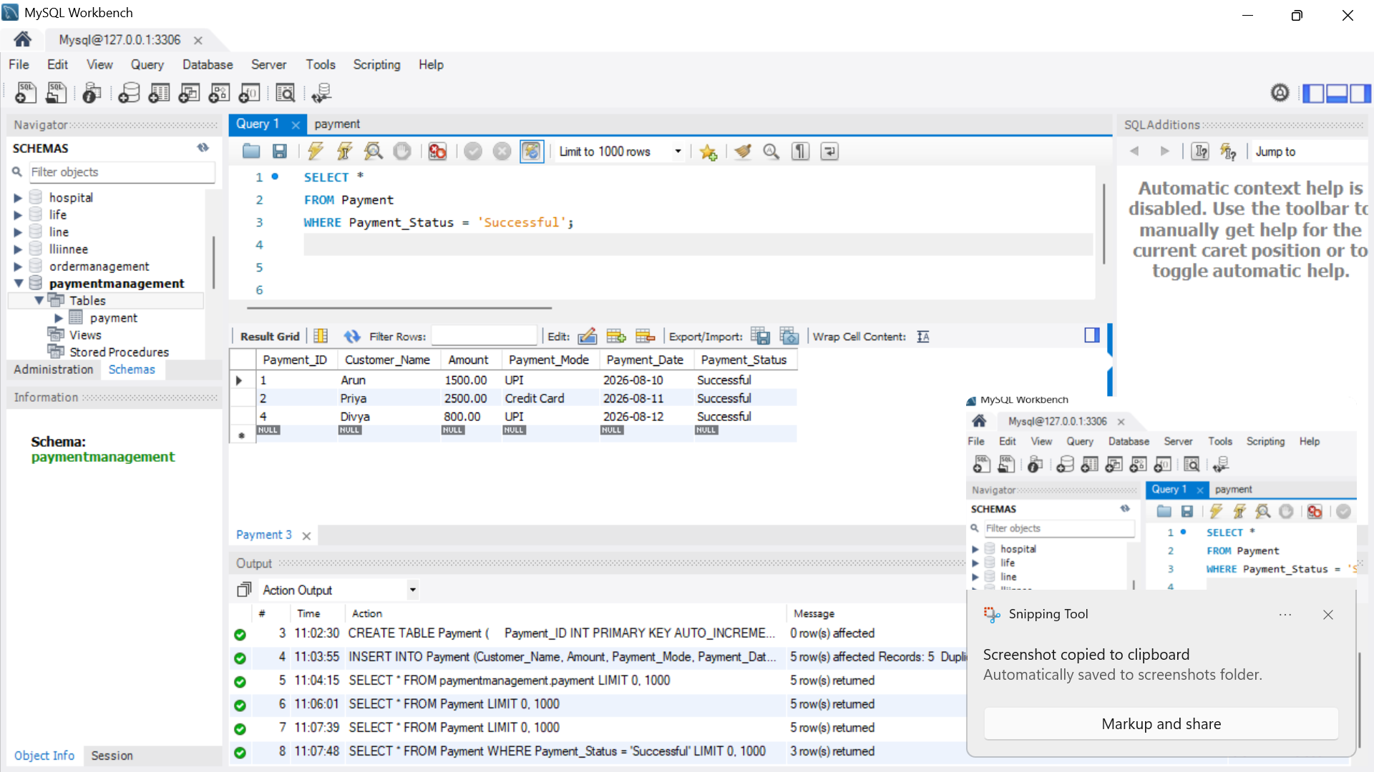

6. Display Failed Transactions
SELECT *
FROM Payment
WHERE Payment_Status = 'Failed';

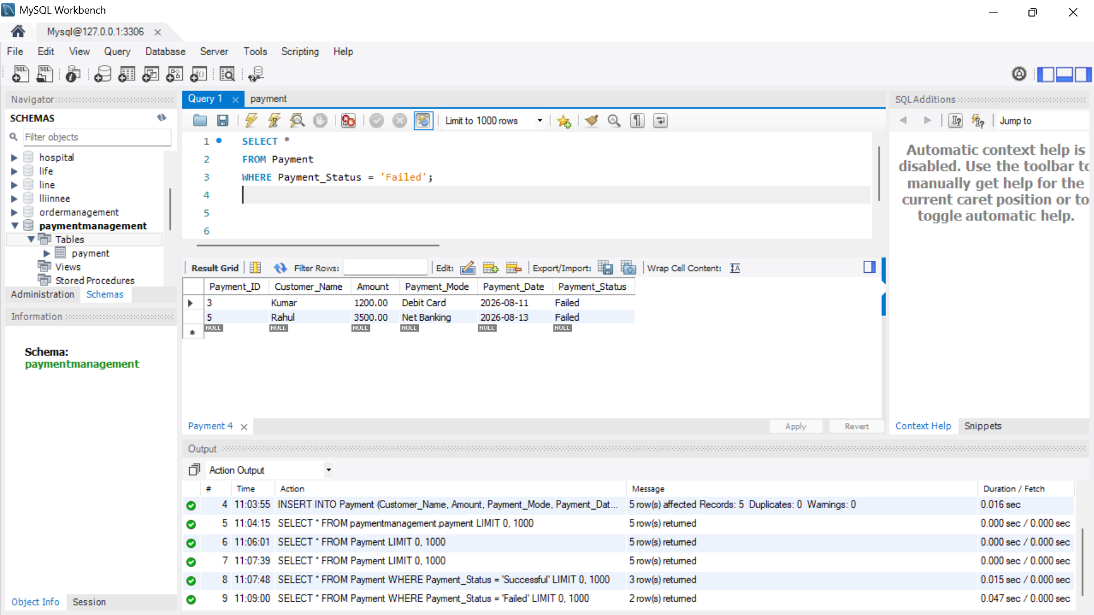
7. Analyze Payment Methods Used
SELECT Payment_Mode, COUNT(*) AS Total_Transactions
FROM Payment
GROUP BY Payment_Mode;

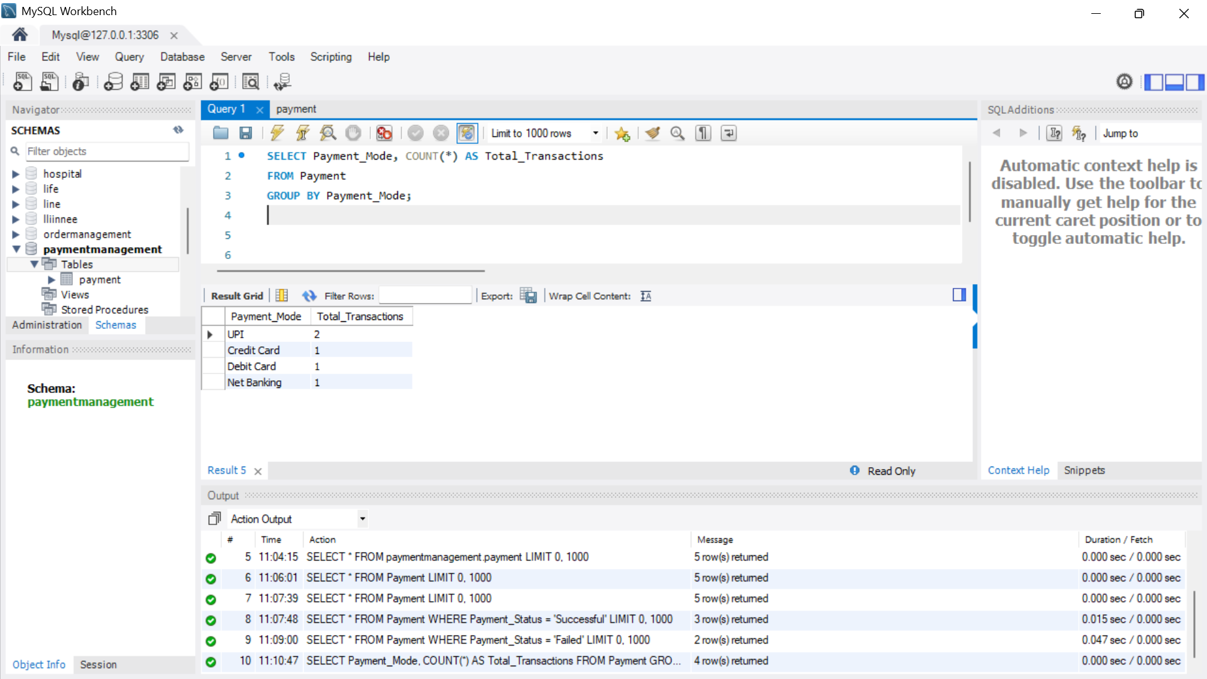
8. Find Total Successful Payment Amount
SELECT SUM(Amount) AS Total_Successful_Amount
FROM Payment
WHERE Payment_Status = 'Successful';

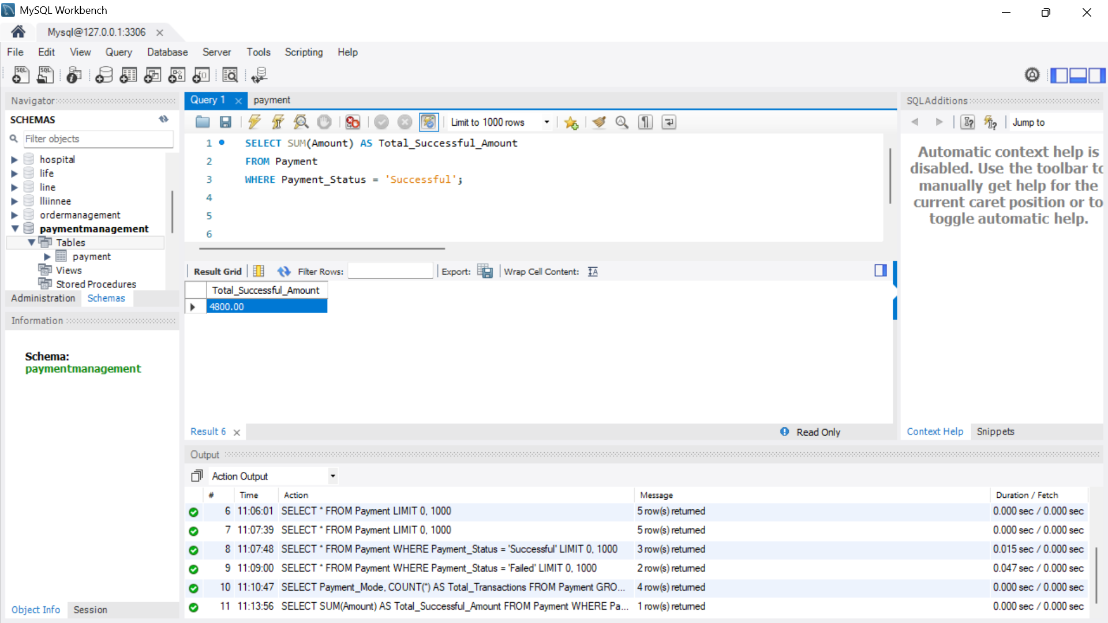

9. Count Successful and Failed Transactions
SELECT Payment_Status, COUNT(*) AS Total
FROM Payment
GROUP BY Payment_Status;

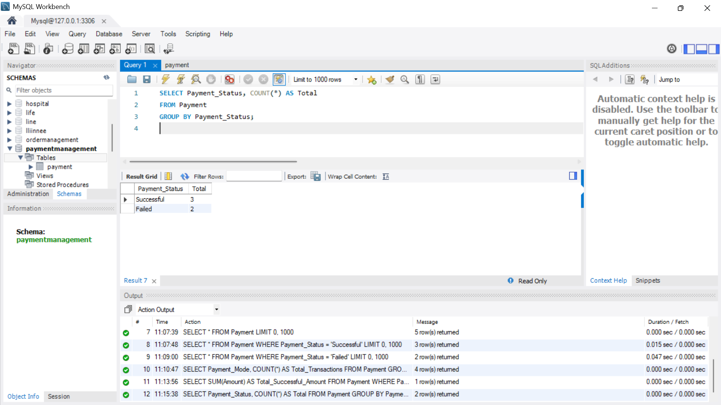

10. Generate Payment Transaction Report
SELECT
Payment_ID,
Customer_Name,
Amount,
Payment_Mode,
Payment_Date,
Payment_Status
FROM Payment
ORDER BY Payment_Date DESC;

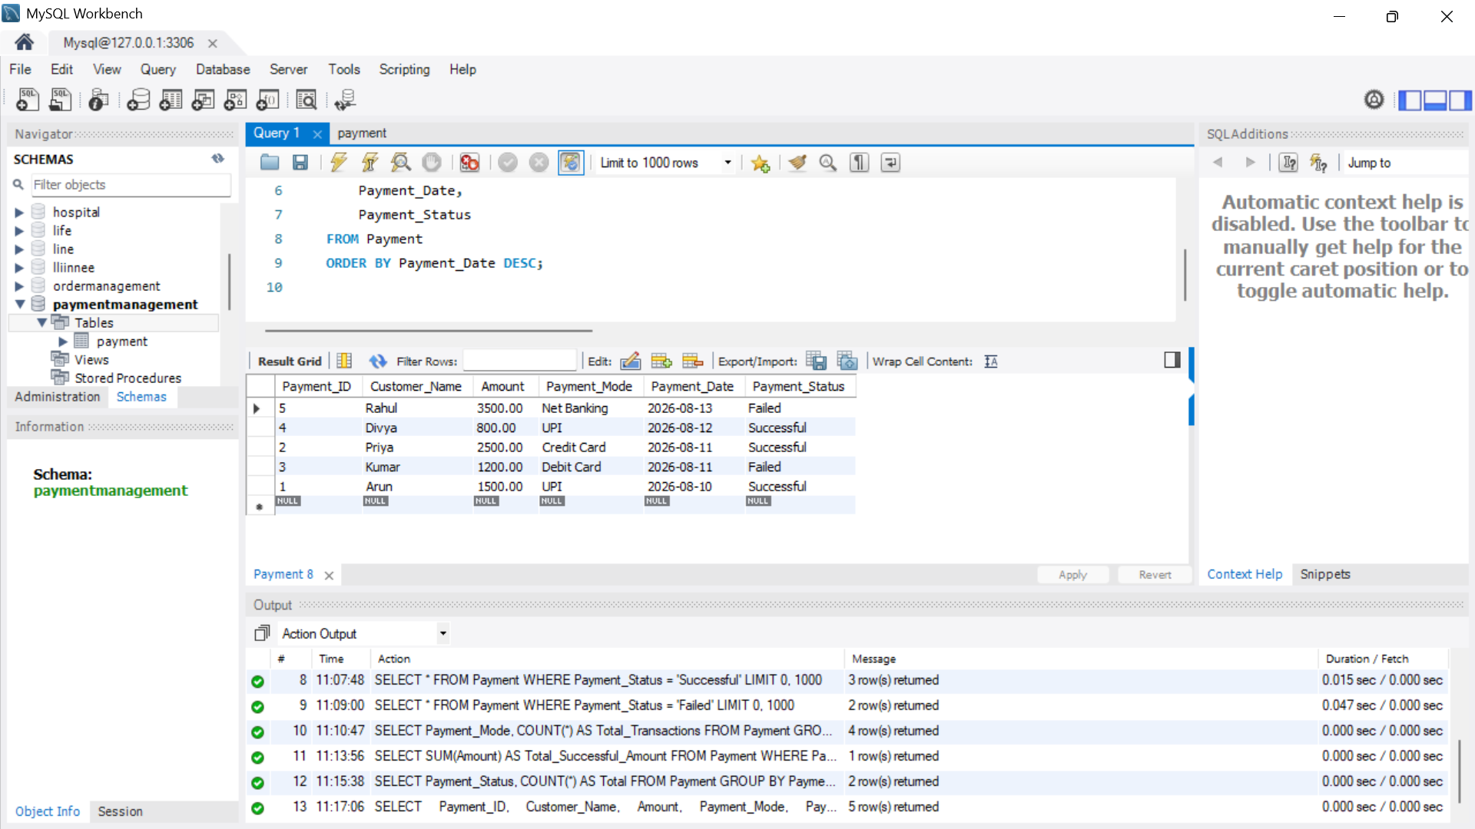

11. Find Total Amount by Payment Method
SELECT
Payment_Mode,
SUM(Amount) AS Total_Amount
FROM Payment
WHERE Payment_Status = 'Successful'
GROUP BY Payment_Mode;

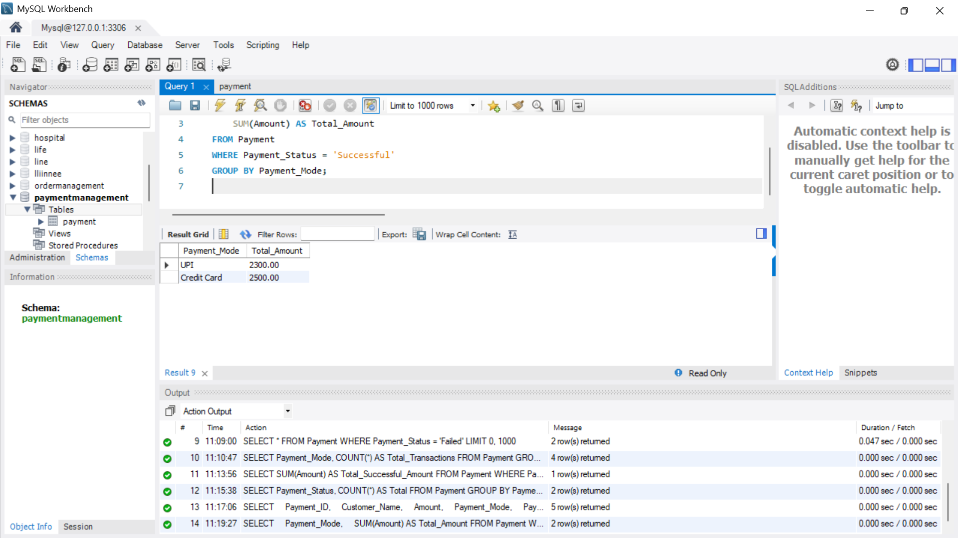
12. Modify a Transaction
UPDATE Payment
SET Payment_Status = 'Successful'
WHERE Payment_ID = 3;

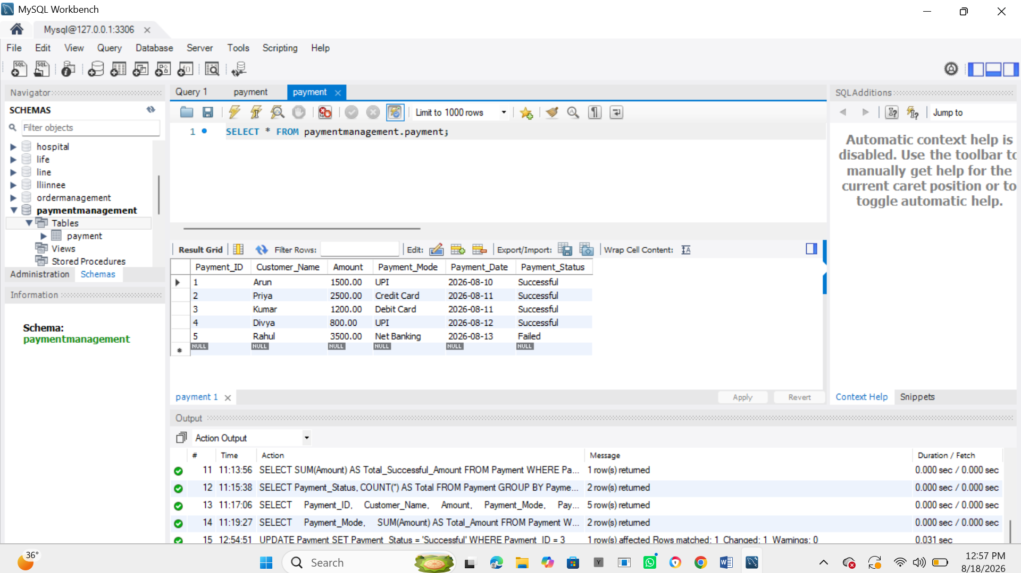
13. Delete a Transaction
DELETE FROM Payment
WHERE Payment_ID = 5;

